**NAME:PAREENITA A.SHIRSATH PRN:221101062 T.E.A.I.&.D.S. ROLL NO:52**

**WEB COMPUTING ASSIGNMENT 2**

**1.WRITE A JS CODE TO DISPLAY A DIGITAL CLOCK.**

**OUTPUT:**

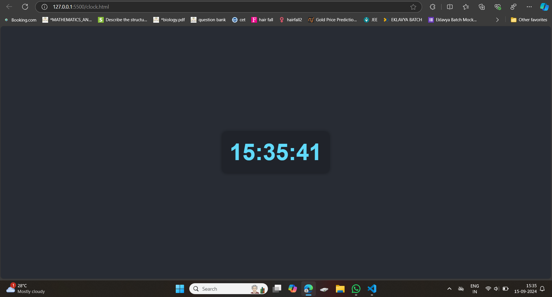

**2.WRITE A JS CODE TO CHANGE COLOR OF THE BACKGROUND AUTOMATICALLY AFTER EVERY 5 SECONDS.**

**OUTPUT:**

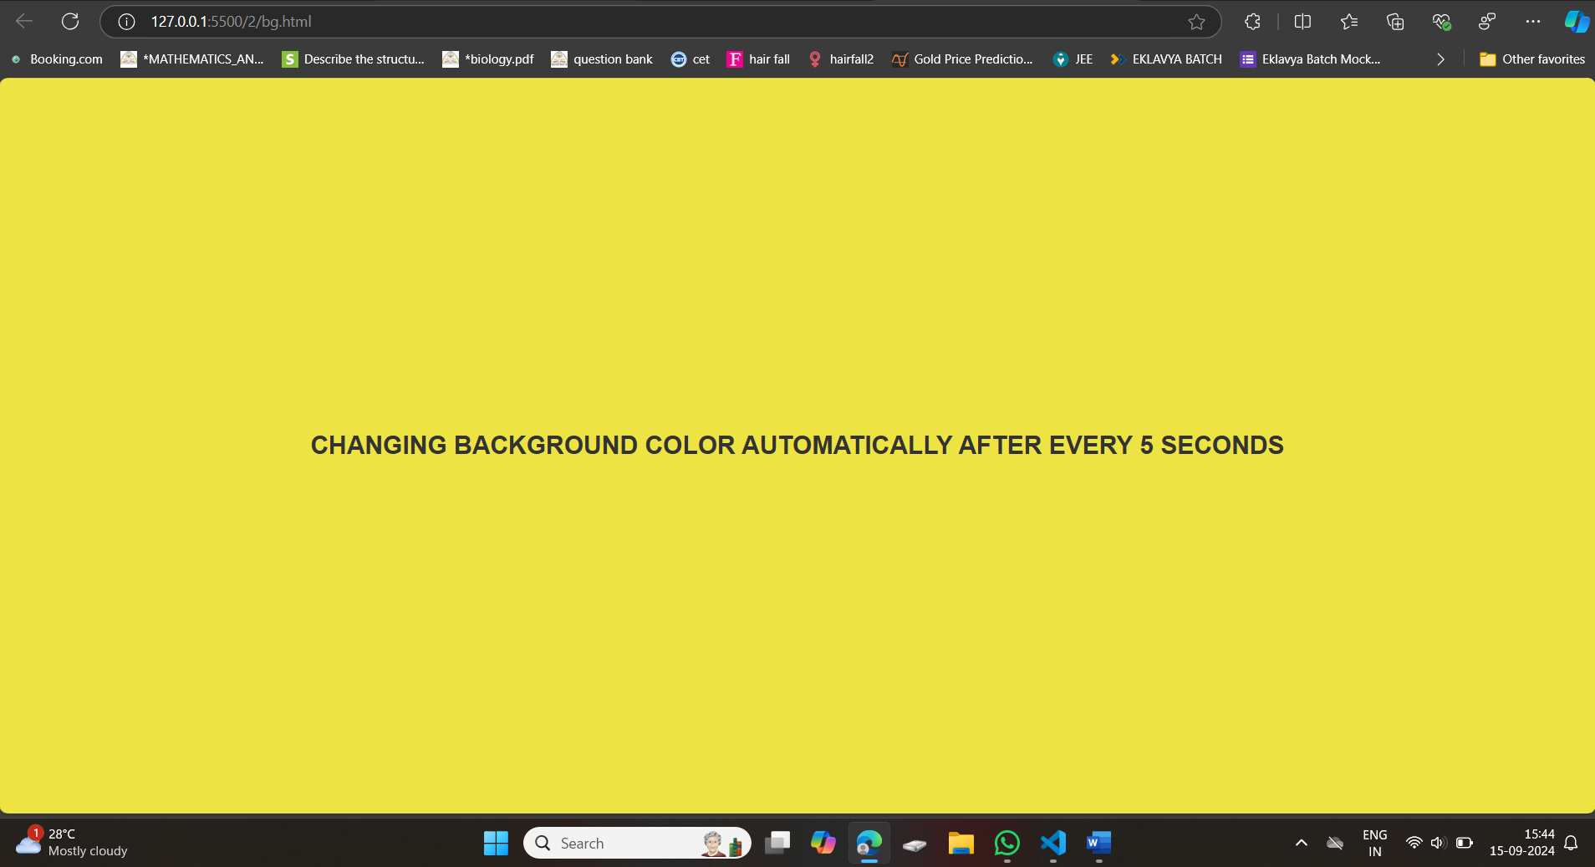

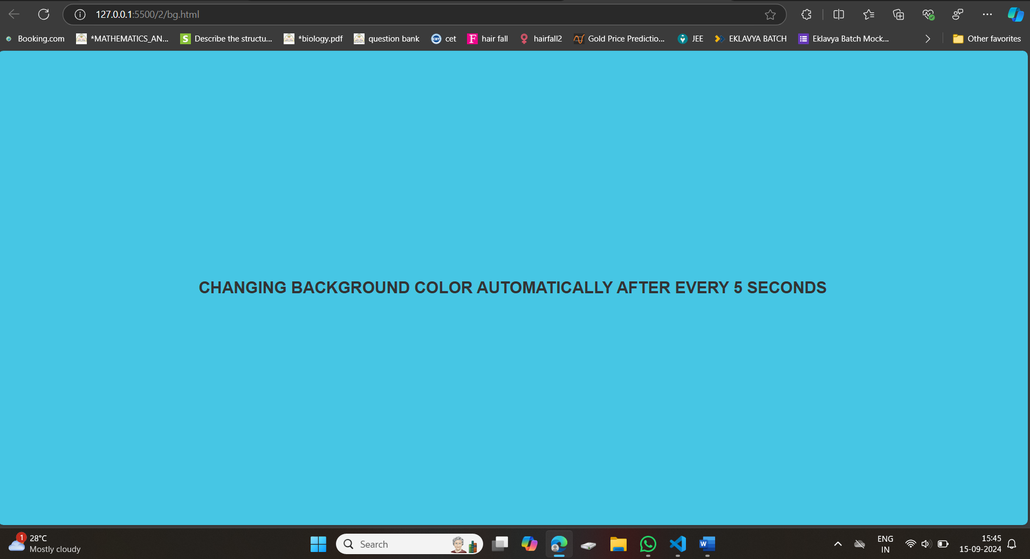

**3.** **Write a js code to accept number from user and check if it is even or odd.**

**OUTPUT:**

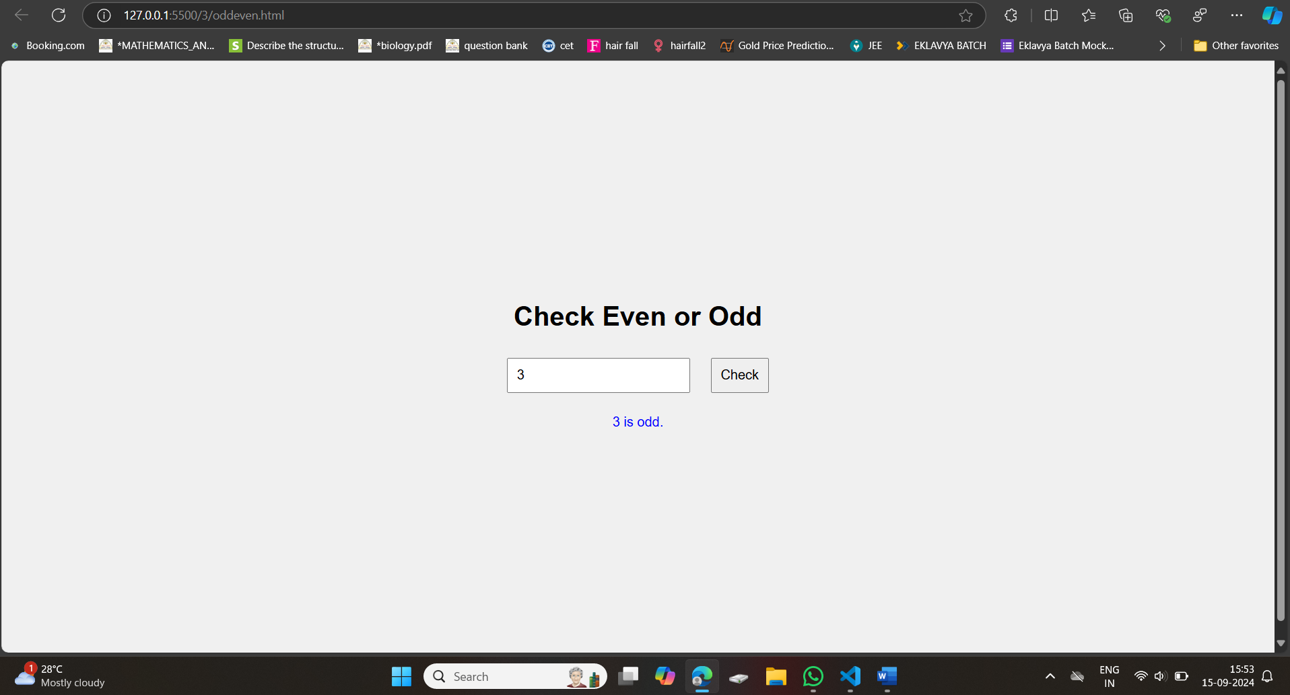

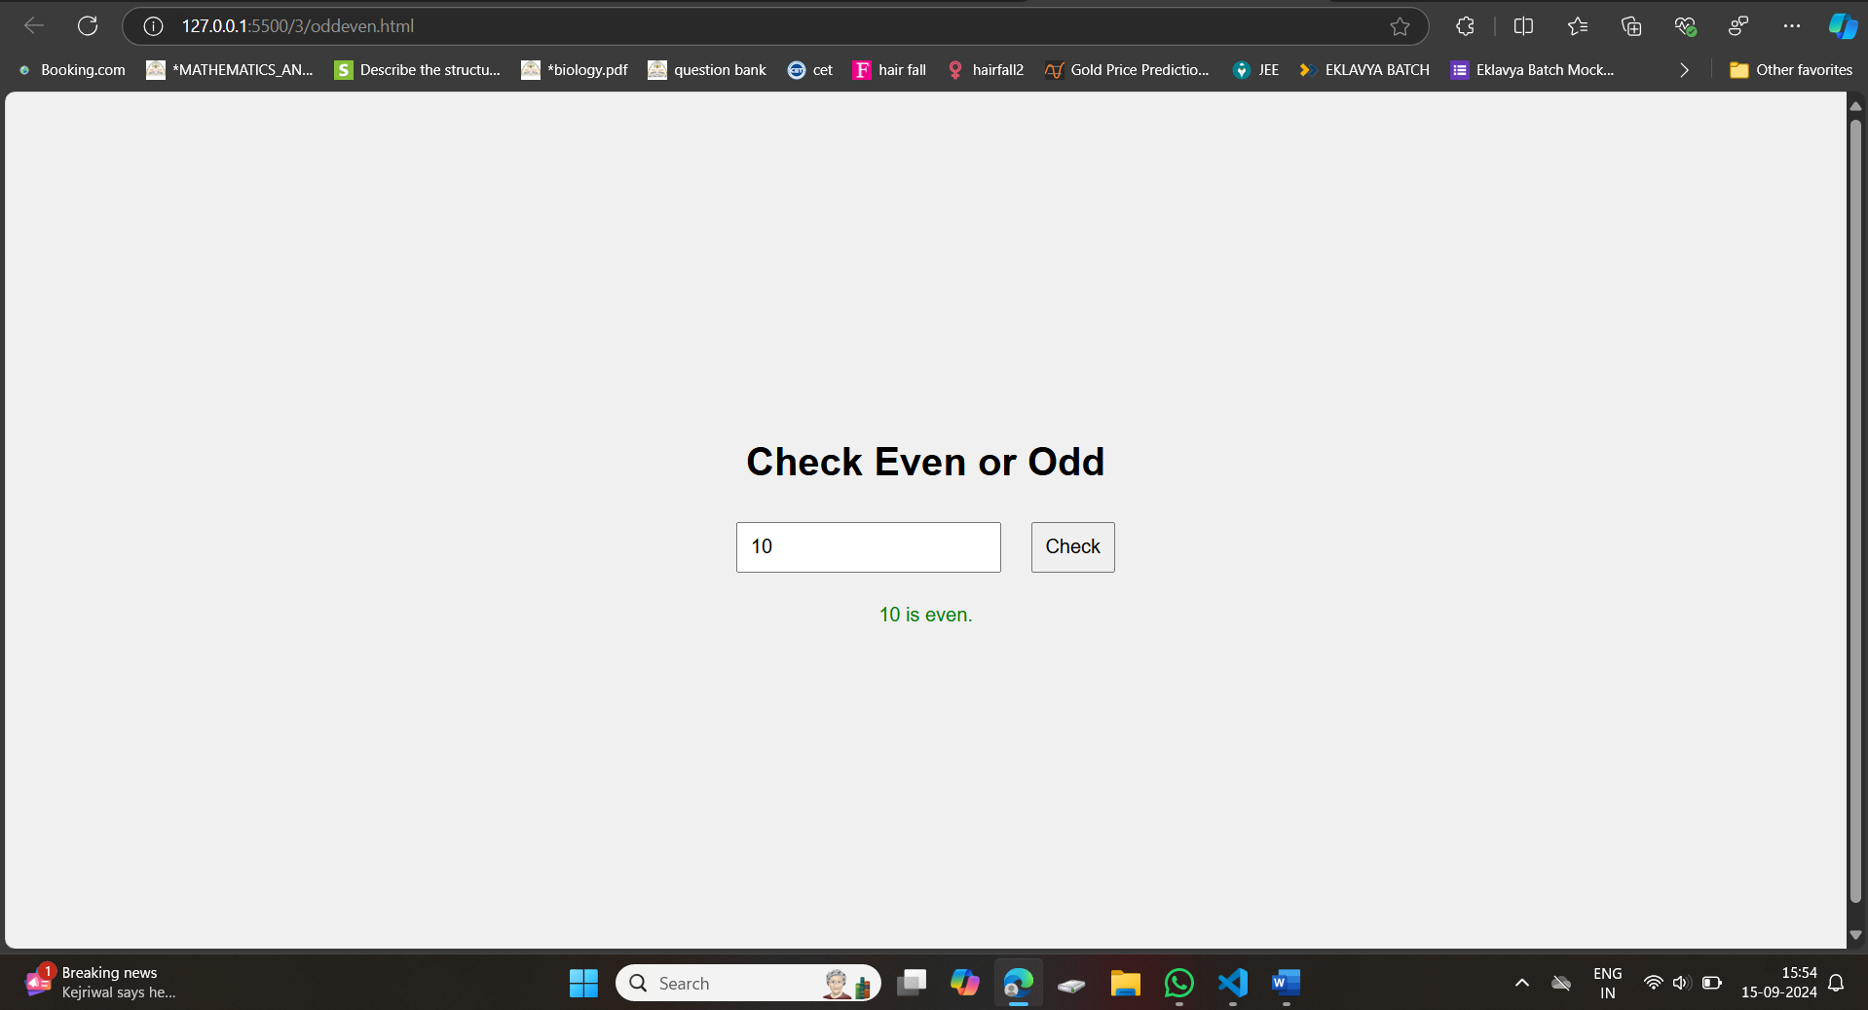

**4.** **Write a js code to validate username password and email id.**

**OUTPUT:**

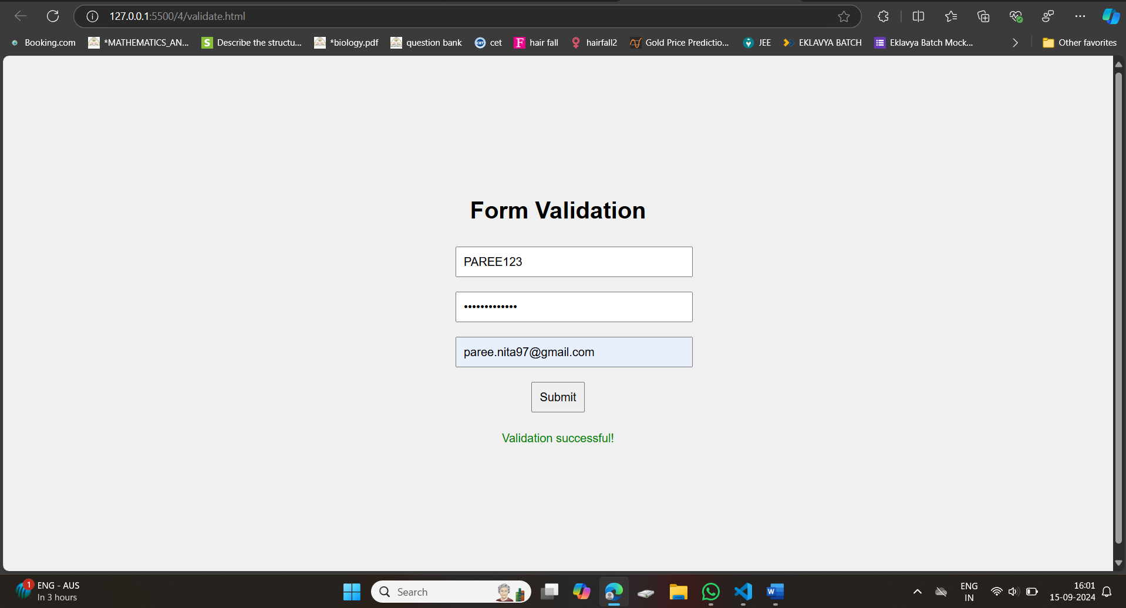

**5.** **Write a js code that reads 10 numbers and display the count of positive ,negative and 0.**

**OUTPUT:**

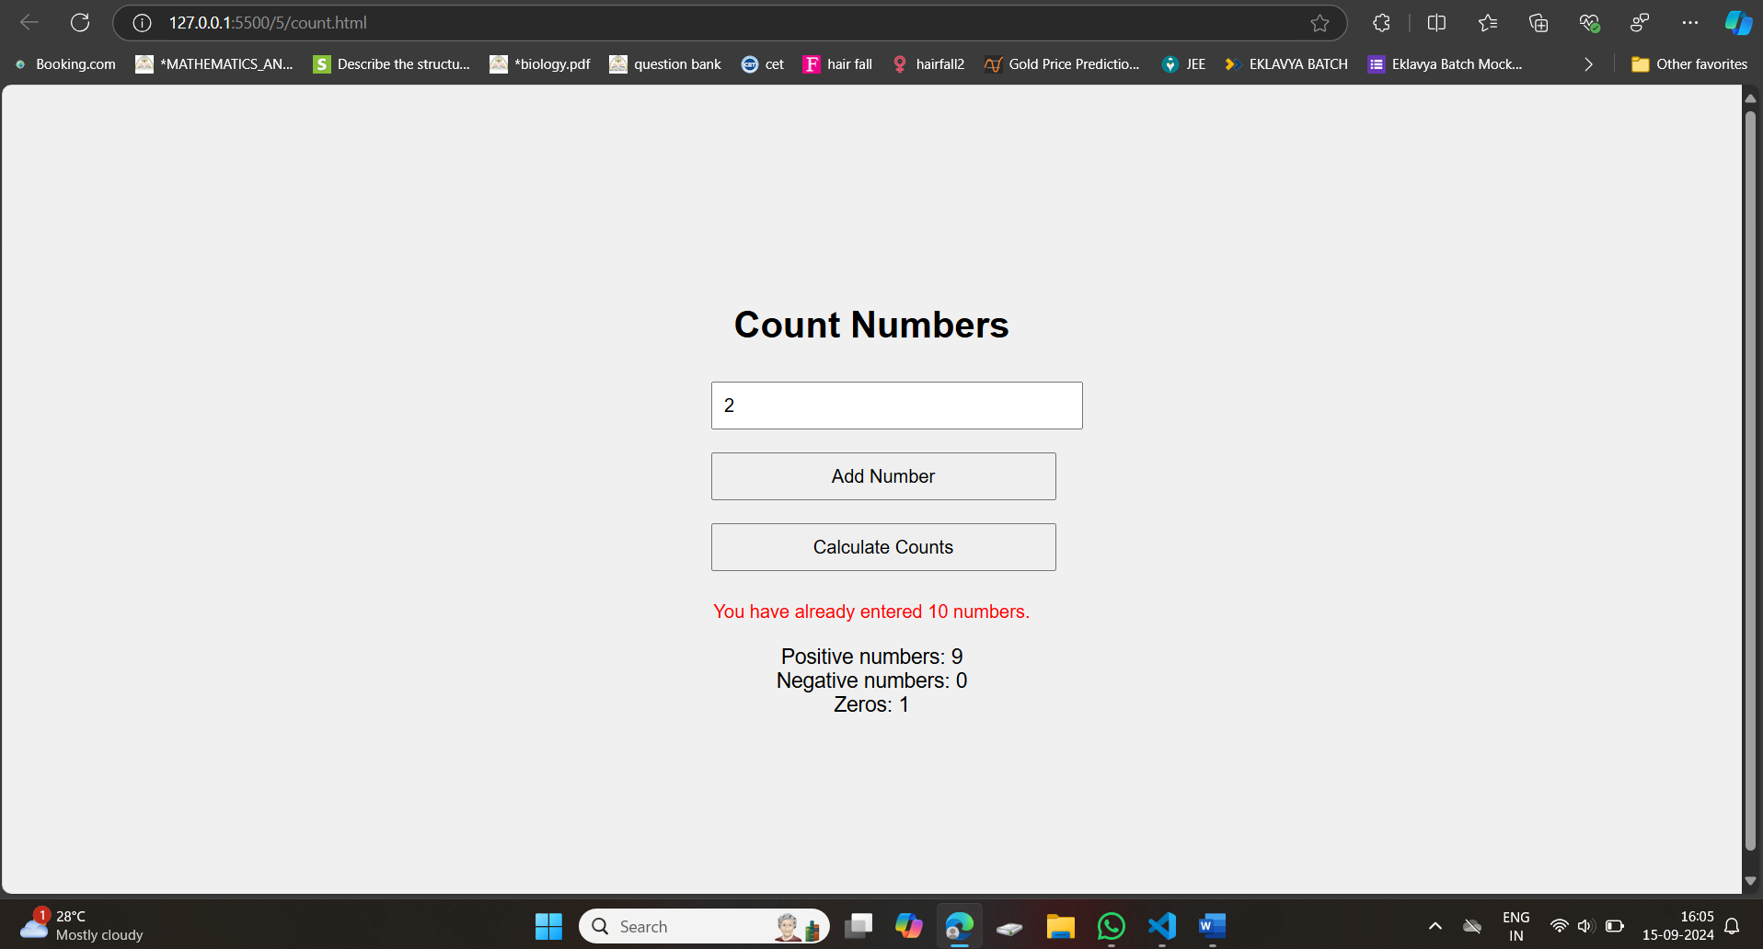

**6.Write a js code to check password and confirm password are same or not.**

**OUTPUT:**

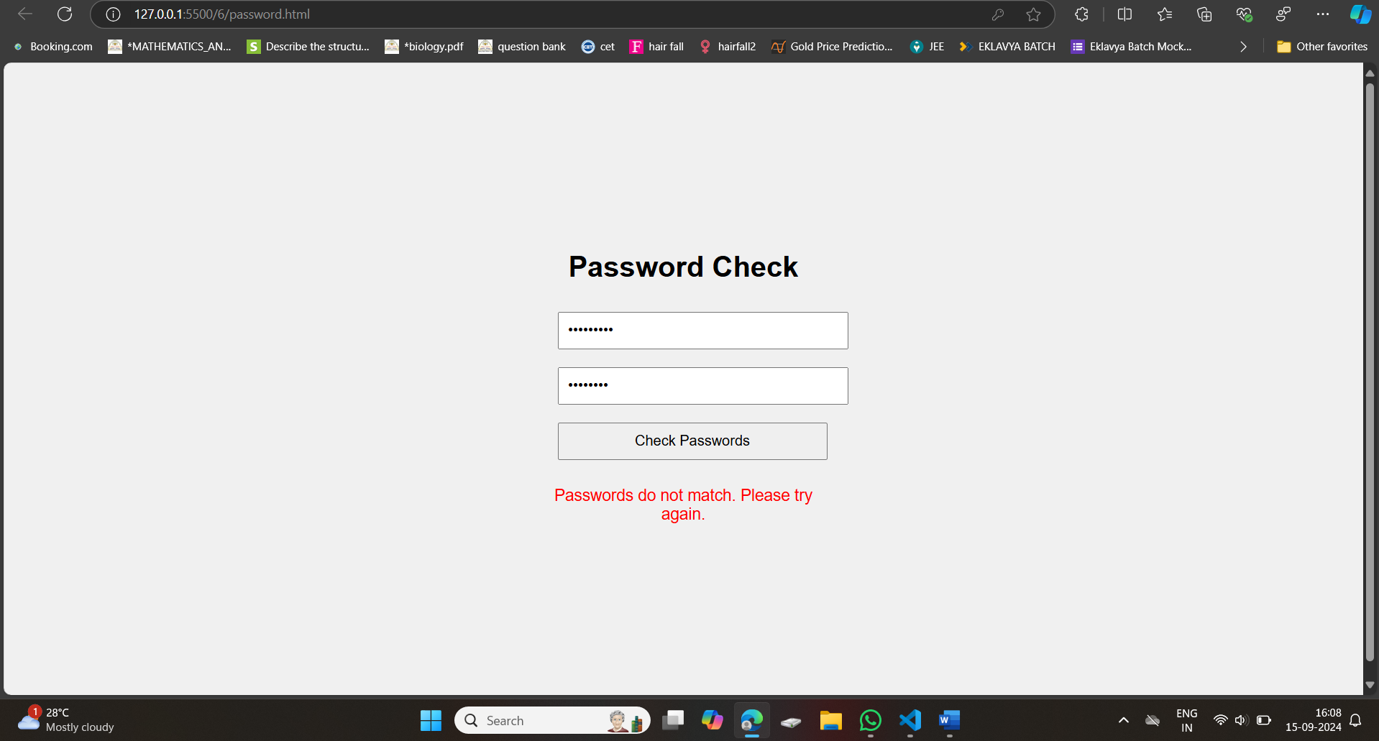 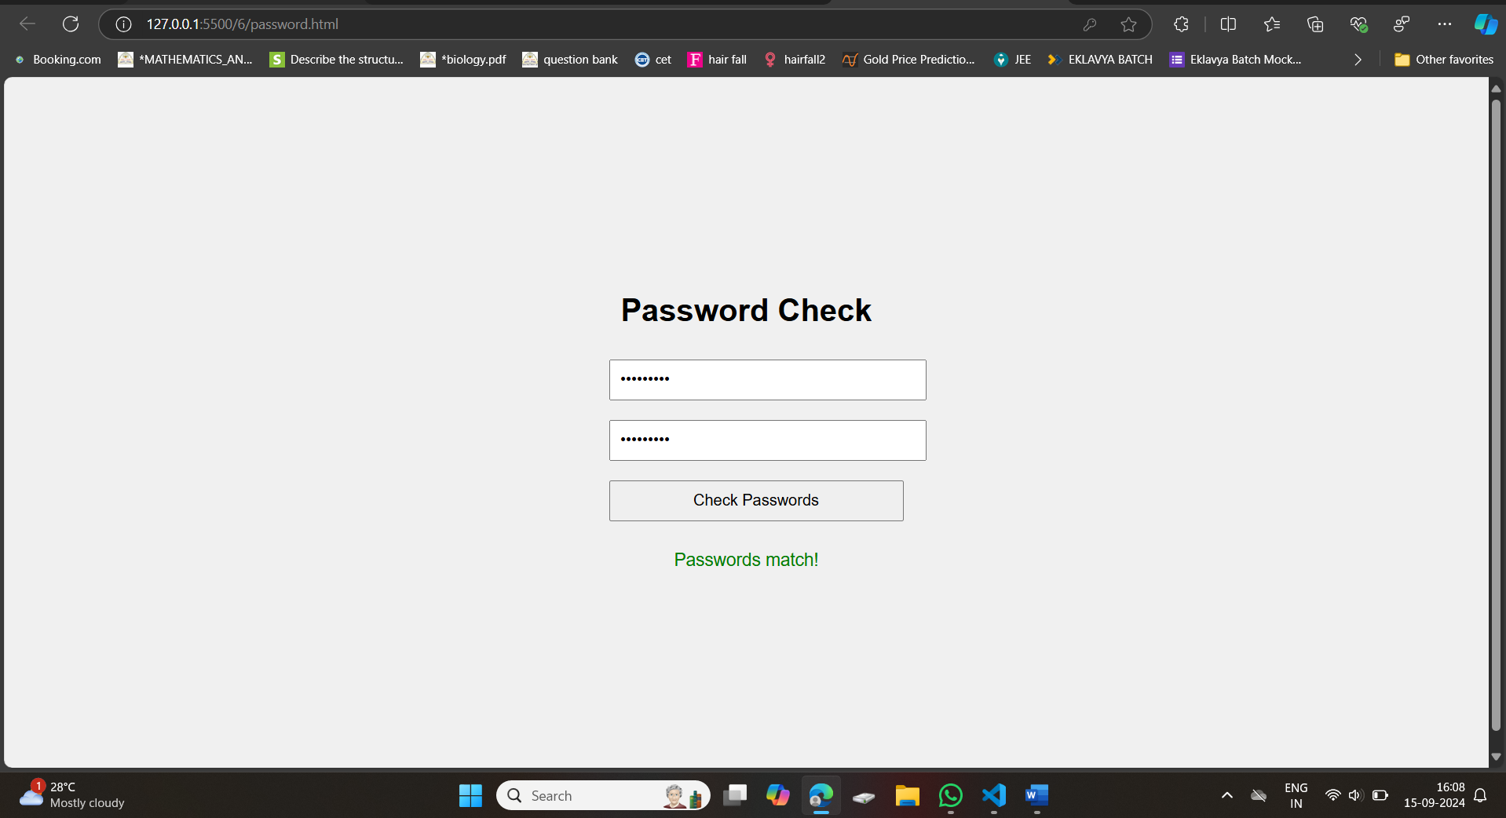

**7.Write a js code to set a cookies in the user computer.**

**OUTPUT:**

